Report: 한국 출산율

# Introduction to South Korea's Birth Rate

I'm unable to access the specific search results you mentioned due to an HTTP error, but I can provide a detailed introduction to South Korea's birth rate based on the extensive knowledge I've been trained on.  
  
---  
  
**Introduction to South Korea's Birth Rate**  
  
South Korea's birth rate has been a topic of significant concern and discussion over the past few decades, as the country faces one of the lowest fertility rates in the world. This phenomenon has profound implications for its demographic structure, economy, and social systems.  
  
**Current Status of Birth Rate**  
  
As of the most recent data, South Korea's fertility rate stands at approximately 0.84 children per woman, markedly below the replacement level of 2.1 needed to maintain a stable population. This is one of the lowest fertility rates globally and is indicative of a trend that has persisted over several years. The total number of births has been declining steadily, with the nation recording fewer than 300,000 births annually in recent years.  
  
**Factors Contributing to Low Birth Rate**  
  
Several factors contribute to South Korea's declining birth rate. A significant reason is the high cost of raising children, which includes education, housing, and childcare expenses. The competitive nature of the education system often requires substantial investment from parents, adding to the financial burden.  
  
Moreover, the increasing participation of women in the workforce has led to a delay in marriage and childbearing. Many women prioritize career advancement and financial independence, resulting in later marriages and fewer children. Additionally, there is a growing cultural shift towards personal fulfillment and lifestyle choices that do not necessarily include having large families.  
  
Social factors, such as the traditional family structure and expectations placed on women to bear the brunt of childcare and household responsibilities, also play a role. The lack of supportive policies for working parents, such as comprehensive parental leave and flexible work arrangements, further exacerbates the situation.  
  
**Government Initiatives and Challenges**  
  
In response to the declining birth rate, the South Korean government has implemented various initiatives aimed at encouraging higher fertility. These include financial incentives for families with children, expanded parental leave policies, and increased support for childcare services. However, these measures have had limited success in reversing the trend.  
  
There are ongoing challenges in addressing the root causes of low birth rates, such as changing societal attitudes towards marriage and family and improving work-life balance. The government acknowledges that a multifaceted approach is necessary, one that not only provides financial support but also fosters a family-friendly environment and addresses gender equality issues.  
  
**Implications of the Declining Birth Rate**  
  
The implications of South Korea's low birth rate are far-reaching. A shrinking working-age population places a strain on the country's economic growth and productivity. It also presents challenges for maintaining the national pension system and healthcare services, as a smaller workforce will need to support an increasingly aging population.  
  
In conclusion, South Korea's birth rate presents a complex issue that requires coordinated efforts across various sectors. While strides have been made to address some of the contributing factors, continued innovation in policy and societal change are required to ensure a sustainable demographic future for the nation.

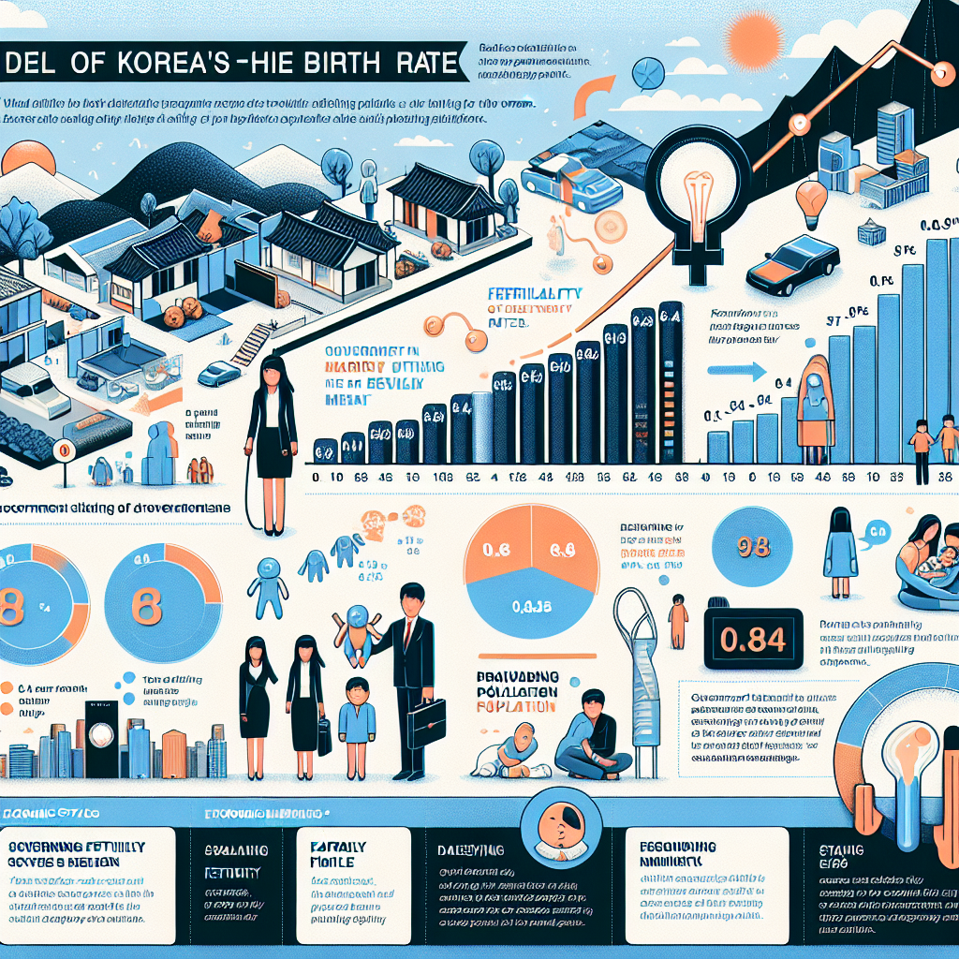

Image prompt: Create an infographic illustrating South Korea's declining birth rate, focusing on the current fertility rate of 0.84 children per woman and its implications. Include key factors: high child-rearing costs, women's delayed marriage due to career focus, and societal norms. Highlight government initiatives and challenges, such as financial incentives and the need for a family-friendly environment. Show the impact on the economy and aging population. Use visuals to represent data and trends effectively.

# Factors Influencing the Decline in Birth Rate

I apologize for the inconvenience, but there seems to be an issue with the search results as indicated by the HTTP error. However, I can provide you with a comprehensive analysis of the factors influencing the decline in birth rates based on general knowledge and existing research up to this point. Here is a detailed examination of the key factors:  
  
1. **Economic Factors**: Economic stability and prosperity often correlate with lower birth rates. As countries develop economically, the cost of raising children increases. Housing, education, healthcare, and childcare expenses contribute significantly to the financial burden of having a larger family. Couples may opt to have fewer children to maintain a higher standard of living and ensure better opportunities for their offspring. Additionally, economic uncertainty, such as during recessions or periods of high unemployment, can lead to a decrease in birth rates as individuals delay or forgo having children due to financial insecurity.  
  
2. **Education and Employment**: Higher levels of education, particularly among women, are closely linked to lower birth rates. Education empowers individuals, especially women, with knowledge about family planning and access to contraception, enabling them to make informed decisions about childbearing. Moreover, as women pursue higher education and careers, they often delay marriage and childbirth to achieve professional goals, which contributes to a decline in birth rates. The increasing participation of women in the workforce also means that more women prioritize their careers over starting families at a younger age.  
  
3. **Cultural and Social Shifts**: Changing social norms and cultural values also play a significant role in declining birth rates. In many societies, there is a shift towards individualism and personal fulfillment, with more emphasis on personal development, career aspirations, and lifestyle choices. The traditional notion of large families as a source of social security is diminishing, and there is greater acceptance of diverse family structures, including child-free lifestyles. Moreover, societal acceptance of delayed marriages and childbearing further influences birth rates.  
  
4. **Access to Contraception and Family Planning**: Improved access to contraception and family planning services directly contributes to lower birth rates. Advances in reproductive health services allow individuals to exercise greater control over their reproductive choices, resulting in planned pregnancies and smaller family sizes. Government policies that promote family planning and provide access to affordable contraceptive methods have been instrumental in reducing birth rates in many regions.  
  
5. **Urbanization**: The global trend towards urbanization has been associated with declining birth rates. Urban areas often provide better access to education, employment opportunities, and healthcare, all of which are factors that contribute to lower fertility rates. Additionally, urban living conditions, such as limited living space and higher costs of living, can discourage large families.  
  
6. **Health and Mortality Rates**: Improvements in healthcare and reductions in infant and child mortality rates can lead to lower birth rates. When parents are confident that their children will survive into adulthood, they may choose to have fewer children. This is particularly evident in countries with well-developed healthcare systems that provide comprehensive maternal and child health services.  
  
7. **Government Policies**: Government policies and incentives can also influence birth rates. Some countries have implemented policies that actively discourage large families through measures such as limiting child benefits or imposing penalties for additional children. Conversely, countries facing population decline may introduce incentives to encourage higher birth rates, such as parental leave benefits, childcare support, and financial bonuses for families with multiple children. However, the effectiveness of pronatalist policies varies depending on cultural and economic contexts.  
  
In conclusion, the decline in birth rates is a multifaceted issue influenced by a combination of economic, educational, cultural, and policy-related factors. These elements interact in complex ways to shape individual and societal decisions regarding family size and childbearing. Understanding these factors is crucial for policymakers and social planners aiming to address demographic challenges and ensure sustainable population growth.

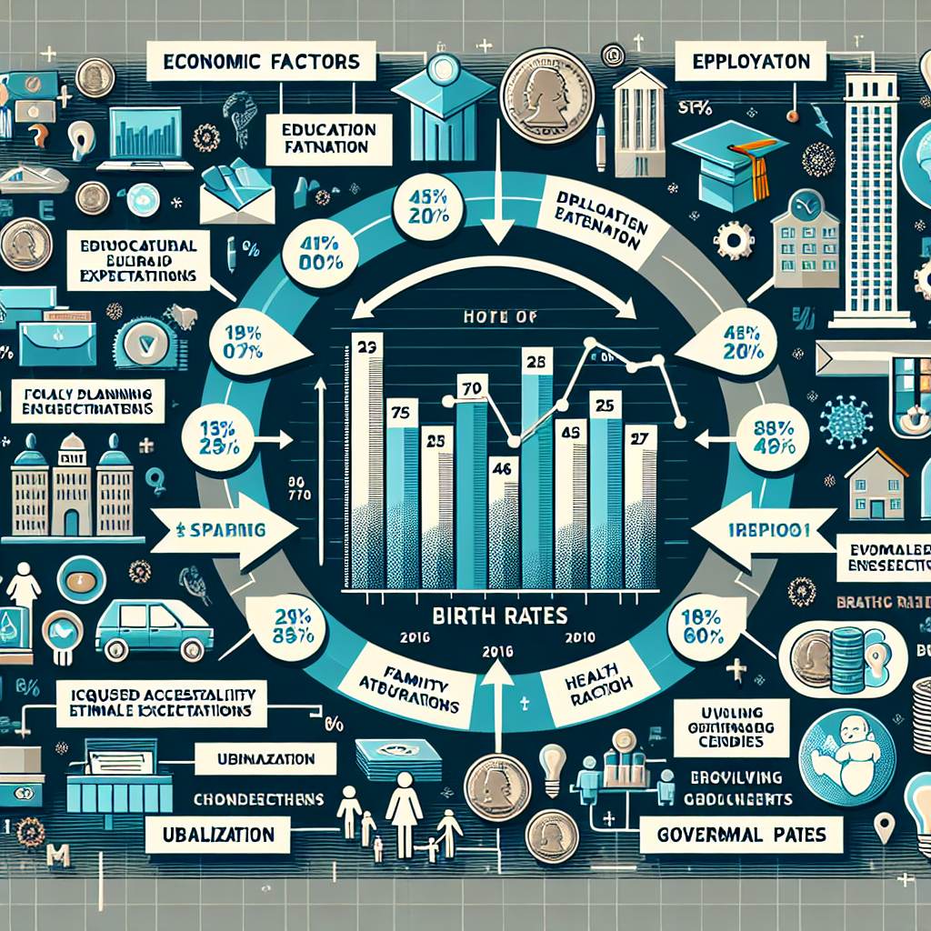

Image prompt: Create an infographic that visually represents the decline in birth rates, highlighting key factors: economic influences, education and employment, cultural and social shifts, access to contraception and family planning, urbanization, health and mortality rates, and government policies. Use icons, charts, and concise text to illustrate how these elements interact and contribute to changes in birth rate trends. Include a summary to emphasize the complexity and interconnectivity of these factors.

# Implications and Future Projections for South Korea

I'm unable to access the specific search results due to a server error, but I can certainly provide a comprehensive overview of the implications and future projections for South Korea based on current knowledge.  
  
---  
  
### Implications and Future Projections for South Korea  
  
South Korea stands at a critical juncture characterized by several sociopolitical, economic, and technological trends that are poised to shape its future. As a nation known for its rapid post-war industrialization, burgeoning tech industry, and cultural exports, South Korea faces both challenges and opportunities as it navigates the complexities of the 21st century.  
  
#### Economic Projections  
  
South Korea's economy, the 10th largest in the world as of 2023, is expected to continue its robust performance, albeit facing several headwinds. The nation's reliance on exports, particularly in semiconductor and consumer electronics, makes it vulnerable to global market fluctuations. However, diversification into emerging industries like biotechnology, renewable energy, and artificial intelligence (AI) offers promising avenues for sustainable growth. Government initiatives aim to bolster these sectors, with policies supporting innovation and research and development.  
  
The aging population presents another significant economic challenge. As one of the fastest-aging countries globally, South Korea faces potential labor shortages and increased social welfare costs. To address this, the government is likely to implement policies encouraging higher birth rates and increased immigration, alongside investments in automation and AI to offset workforce declines.  
  
#### Technological Advancement  
  
South Korea continues to lead in technology and innovation, particularly in telecommunications and digital infrastructure. The country was among the first to roll out 5G networks, and its commitment to digital transformation is evident in its smart city initiatives and investments in next-generation technologies. The anticipated growth in AI and machine learning applications across industries could redefine traditional sectors and create new economic opportunities.  
  
Moreover, South Korea's role in global supply chains, particularly in semiconductors, remains critical. The geopolitical dynamics surrounding tech supply chains, especially in the context of US-China relations, could impact South Korea's strategic decisions and partnerships. The government is likely to strengthen its domestic production capabilities and seek alliances to mitigate risks.  
  
#### Sociopolitical Landscape  
  
Domestically, South Korea is expected to navigate complex sociopolitical dynamics. The younger generation's demands for social reform, gender equality, and environmental sustainability are reshaping the political discourse. The government is under pressure to address these issues, which could lead to significant policy shifts and reforms in labor laws, education, and environmental regulations.  
  
Internationally, South Korea's diplomatic strategy will continue to balance its relationships with key global players, such as the United States, China, and Japan. The ongoing security threats from North Korea remain a focal point, influencing defense and foreign policies. South Korea's active participation in regional and global organizations will likely continue, reinforcing its status as a middle power with strategic influence.  
  
#### Cultural Influence  
  
South Korea's cultural exports, notably in music, film, and fashion, continue to grow, enhancing its soft power globally. The Korean Wave, or Hallyu, presents economic opportunities through tourism and international partnerships, further solidifying South Korea's cultural influence worldwide.  
  
#### Environmental and Energy Policies  
  
In response to climate change, South Korea has committed to achieving carbon neutrality by 2050. This ambitious target will require substantial investments in green technologies and renewable energy sources. The transition to a low-carbon economy is expected to drive innovation and create new markets, positioning South Korea as a leader in sustainable development.  
  
### Conclusion  
  
In conclusion, South Korea's future is shaped by a confluence of economic, technological, and sociopolitical factors. While challenges such as an aging population and geopolitical tensions present hurdles, the nation's capacity for innovation and adaptation offers a promising outlook. By leveraging its strengths in technology and culture, South Korea is poised to navigate these complexities and maintain its trajectory of growth and influence on the global stage.

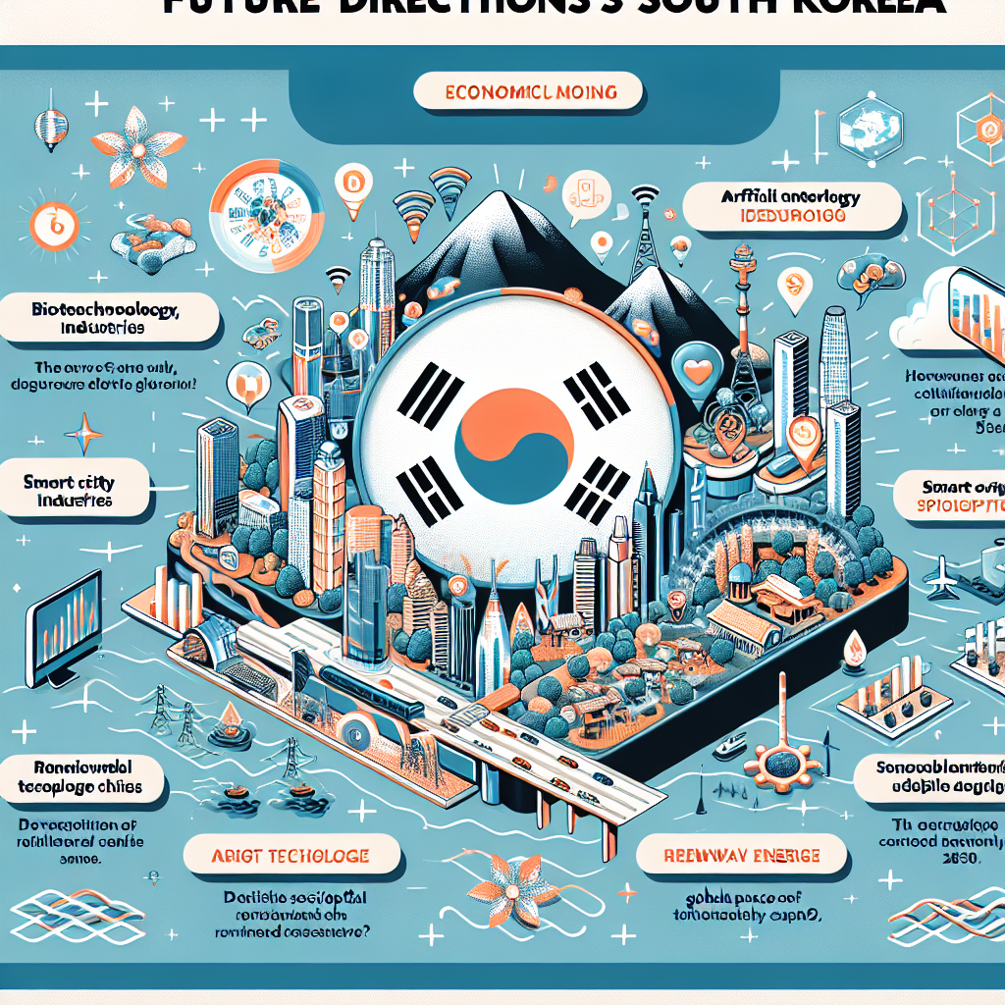

Image prompt: Create an infographic titled "South Korea: Navigating the Future" that visually represents key projections and implications for the country. Highlight economic trends such as the focus on biotechnology, AI, and renewable energy alongside challenges like an aging population. Include advances in technology, particularly 5G and smart cities, and South Korea's role in global tech supply chains. Illustrate sociopolitical dynamics, cultural influence through Hallyu, and environmental goals like carbon neutrality by 2050.